

# Note on methods for measuring child mortality in Inter Aide's health programmes

**July 2024**

**Julie Pontarollo, with the support of Anaïs Duchâtel and Piroska Bisits Bullen**

**Contact: julie.pontarollo@interaide.org**

The aim of this note is to capitalise on the mortality measurement methods used in Inter Aide's community health projects since the early 2000s. As a result of this work, a harmonised method has been deployed across all the programmes concerned from 2022. A summary of the mortality measurements carried out in Madagascar, Malawi, Mozambique and Guinea between 2002 and 2023 is presented in Appendix 1.

# Definitions

**Children under-five mortality rate:** number of deaths of children under five years of age per 1,000 live births, **abbreviated as U5MR**.

**Children under-one mortality rate:** number of deaths of children under one year of age per 1,000 live births, **abbreviated as U1MR**

**Neonatal mortality rate:** number of deaths of children under 28 days of age (born alive but dying between birth and the 28th day of life) per 1,000 live births, **abbreviated as NNMR**. A distinction is made between early neonatal mortality, for deaths during the first week, and late neonatal mortality, for deaths during the following three weeks.

**Perinatal mortality rate:** number of stillbirths (birth after 22 weeks of amenorrhoea of a lifeless foetus) and early neonatal deaths per 1,000 births (including stillbirths).

# Background

**Madagascar -** Under-five mortality was chosen as the key indicator for the community health programme in Madagascar in the early 2000s. This indicator allowed to quickly characterise the overall health status of the vulnerable populations Inter Aide was working with, in the sense that it reflected several essential characteristics: epidemiological and health risks faced by the children and access to qualified care.

At that time, the U5MRs recorded in Manakara district were in the order of 150 ‰ to 200 ‰, and included stillborn children (who are normally excluded from the official definition of U5 mortality). Analysis of the causes of this high mortality showed that malaria (or fevers), diarrhoeal diseases and acute respiratory infections caused more than half the deaths. A study of the healthcare system revealed that access to care was hampered primarily by geographical barriers, with one primary health centre per commune, serving villages that could be more than 4 hours away on foot, and were therefore clearly under-utilised. Against this backdrop, the strategy chosen at the time was to set up a local healthcare service focusing on the main communicable diseases, by training and supplying village health volunteers (or community health volunteers). As a result, infant and child mortality fell by around 50%, reaching a plateau of around 75 ‰ in Manakara district (45 communes, 300,000 people).

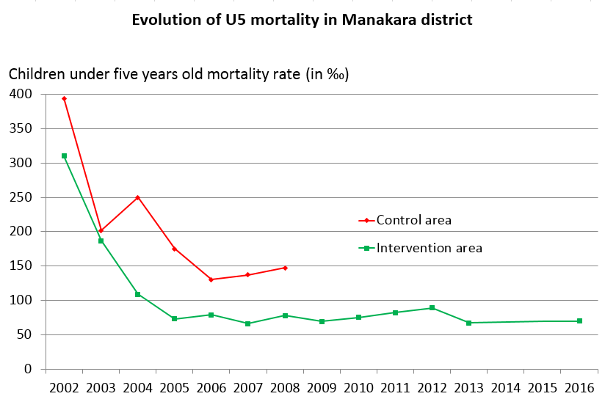

**Table 1.** Results of mortality surveys in Manakara district between 2002 and 2016

Surveys carried out in a control commune (where no intervention had been implemented) showed that mortality was falling elsewhere as a result of the general improvement in the health system, but to a lesser extent than in the area where the village health volunteers supported by Inter Aide were working.

In the 2000s, the **direct 5-year extrapolation method** (see paragraph C) was used for exhaustive mortality surveys (including all the houses in the commune) and data collection was carried out each year by village health volunteers, supervised by the Inter Aide team. An external evaluation carried out in 2007 validated this methodology, while highlighting its limitations ([link to the study report](https://reseau-pratiques.org/evaluation-externe-du-programme-de-lutte-contre-la-mortalite-infantile-a-manakara-madagascar-ia-steps-f3e-2007/)).

The programme was then extended to Farafangana, where the methodology used with the village health volunteers proved unsuccessful, as the data was not consistent from one year to the next. Surveyors were then recruited as part of the Inter Aide team in order to improve the quality of data collection by relying on professionals. This method is still used today in Madagascar, sometimes with the support of temporary surveyors. Between 2008 and 2022, a 52% drop in the U5MR was observed in Farafangana (31 communes, 360,000 people), from 177‰ to 85‰ births (including stillbirths). The proportion of deaths attributable to the three communicable diseases treated by village health volunteers fell from 54% to 26%, demonstrating the contribution of volunteers to the reduction of mortality specifically linked to the diseases they treat at community level.

From 2017, the action reached Vohipeno district (21 communes, 150,000 people). The protocol was improved at that time to exclude stillborn babies from the calculation of infant and child mortality. In 16 communes surveyed (80% of the population) between 2017 and 2020, the U5MR was measured at 67‰ excluding stillbirths, and 94‰ stillbirths included. This therefore corresponded to an initial mortality almost half that in Farafangana before intervention, with a weight of the three diseases targeted by the programme of 31%. These figures were almost identical to the results achieved after the intervention in Farafangana district, and therefore raised questions about our ability to achieve results in this context, through an action focused solely on village health volunteers.

In addition to the difficulty posed by an already "low" initial mortality rate, a methodological change has affected the accuracy of the results provided by these surveys. Following an external evaluation in 2017, data collection was changed from exhaustive to sampled, with the aim of saving our resources. The results obtained in this way were not sufficiently precise to allow comparisons and statistically significant conclusions. From 2022 onwards, the surveys are once again exhaustive. This process enabled the systematic introduction of the 95% confidence interval (IC95%, see paragraph C)) and comparison using the chi² (or χ²) statistical test in order to be able to determine whether the differences observed could be considered significant or not (either between two distinct areas, or for the same area at two different periods). The evaluation surveys were carried out between 2021 and 2024 in 8 communes in Vohipeno and their aggregation indicated a 23% drop in the U5MR, from 76‰ to 58‰. However, this drop is borderline significant, with the chi² test indicating a pvalue of 6%. It was therefore not possible to conclude that the project had an overall impact on under-5 mortality in this district.

In the two new districts of Vondrozo and Vangaindrano, the initial surveys targeted a few communes in each district, in 2022 and 2023 (respectively). The U5MRs observed are around 150‰ (excluding stillbirths), i.e. of the order of the initial mortality observed in Manakara and Farafangana before intervention. They thus suggest a potentially significant impact of the programme's action in this context and confirm the elements collected during the exploratory visits. All the results of the mortality surveys are shown in Appendix 1.

**Malawi -** When the health programme strategy was revised in 2014 to include support for the care system up to health centre level, an important baseline survey was carried out in Lilongwe and Phalombe districts, and the various mortality rates were defined using the **birth history method** (see paragraph C). This protocol corresponds to the standard method for mortality calculation (see the United Nations reference document in Appendix 2) and made it possible to establish precise initial indicators with relatively simple calculations (see the report of the Mitundu survey on the [Réseau Pratiques](https://reseau-pratiques.org/enquetes-initiales-pour-le-projet-de-sante-materno-infantile-en-zone-rurale-au-malawi-2014-et-2015/)). It is based on a **real cohort of children** monitored over 5 years. In Lilongwe, external stakeholders with links to the local university community and the health authorities were involved in coordinating and setting up the study, but this partnership experience was not subsequently repeated.

However, when the survey was repeated 3 years later, the calculation used to measure the impact on the recent period (the last three years of intervention) proved to be much more complex (**synthetic cohort of children,** see paragraph C). In addition, the birth history method, although applicable to a relatively small sample (around 500 families per study area), was associated with a very long questionnaire (around a hundred questions) and required very well-trained professional interviewers. The new calculation method required and the complexity of data collection led to a lack of reliability in the results of the evaluation surveys in 2017. In 2020, a final attempt was made with this protocol, which was confirmed to be complex in terms of data collection and analysis. Despite being interrupted at the time of the Covid-19 pandemic, these surveys nevertheless showed a reduction in U5MR of 28%, 71% and 37% in the various targeted health areas from 2014 onwards, as well as a reduction of 56% in the control zone. The impact of the intervention on mortality was therefore not formally demonstrated during this first phase in Malawi.

From 2022, the **direct 5-year extrapolation method** was introduced in Malawi, making it possible to assess mortality at the end of the intervention in some areas. Unfortunately, these results are not directly comparable with the measurements at the start of the intervention and have made it difficult to assess the impact in Malawi since the launch in 2014 (see compilation in Appendix 1).

That said, recent results in Malawi suggest that a significant decline in mortality has taken place in the country even in rural areas (outside the programme intervention), from 100 to 150‰ in the years 2014-2015 to around 20 to 50‰ in the 2020s. These results seem consistent with the relatively high consultation index observed in Malawi, where the health system is more functional than elsewhere (between 1.5 and 2 consultations per year per child before intervention, compared with 0.3 in Guinea and Madagascar). Neonatal deaths now account for around 50% of mortality. These results are consistent with the strategic direction of the programme in Malawi, which now focuses on improving the quality of care provided up to the health centre, rather than on the accessibility of treatment. The extension of the intervention to maternal and reproductive health also targets the growing proportion of mortality attributable to risks during pregnancy and the first days of life.

**Mozambique -** The process was relatively similar to that in Malawi. When the health programmes were launched in 2016 in the districts of Monapo and Memba, the **birth history method**, coupled with a long questionnaire, was used to establish initial mortality levels and to carry out an in-depth study of the health situation in these areas. This protocol was used again in 2018, with the same difficulties observed in Malawi: complexity of data collection, difficulty in analysing the recent impact of the programme. It was on this occasion that the mortality calculation methods were compared, particularly using the Memba. This showed the difference in results obtained from the same data collection, between the **direct 5-year extrapolation method**, the **direct 5-year extrapolation method** and the **direct method using mortality rates**. The choice of a standard protocol for all of Inter Aide's health programmes stems from this work: the **direct 5-year extrapolation method** was introduced in Mozambique in 2021 and digital data collection on smartphones (using Kobo software) in 2022. The initial level of U5MR observed in Mozambique before intervention is approximately 115‰ in 2022.

**Guinea -** As part of the opening of the health programme in 2021, the **direct 5-year extrapolation method** was chosen for the initial surveys and made it possible to measure initial mortality rates in two communes (digital collection on Kobo). The levels recorded (251‰ and 308‰) are particularly worrying. Although carried out during a measles epidemic that may have increased mortality, the three communicable diseases (malaria, diarrhoea and acute respiratory infections) cause 55% of deaths on average, which shows the value of a programme focusing on these pathologies.

# Different methods of measuring mortality

The methods for collecting data and calculating mortality are summarised here in a simple and pragmatic way for use in Inter Aide programmes. The characteristics of these methods, their theoretical bases and their limitations are explained for some of them in the reference documents in Appendix 2. Additional information is provided for some methods in Appendix 3. The formulas are entered in the Excel calculation table available on the [the Réseau Pratiques](https://reseau-pratiques.org/note-sur-les-methodes-de-mesure-de-la-mortalite-des-enfants-dans-les-programmes-de-sante-dinter-aide-2023/) website and in Appendix 3.

All the methodologies presented are direct mortality estimation methods based on the children's dates of birth, their current status (survival or death), the dates and causes of death where applicable.

## Direct method using mortality rates

This method is the simplest and does not correspond to a real probability, but to a death rate over a given period. The number of child deaths over a period is divided by the number of births over the same period.

Applied to infant mortality (**U1MR**), we divide the number of deaths of children under one year of age over a period (**U1 Deaths**) by the number of live births over the same period (**Births**).

|  |  |  |
| --- | --- | --- |
| **U1MR =** | **U1 Deaths over a period** |  |
| **Births over the same period** |

Applied to infant and child mortality (U5MR), we divide the number of deaths of children under 5 over a period (**U5 Deaths**) by the number of live births over the same period (**Births**).

|  |  |  |
| --- | --- | --- |
| **U5MR =** | **U5 Deaths over a period** |  |
| **Births over the same period** |

This calculation method has never been used in our projects monitoring-evaluation, but it will be compared with the other methods below for learning purposes.[1]

## Direct 5-year extrapolation method

This method was developed and refined in Madagascar from 2002 onwards. It makes it possible to switch from an annual mortality rate to an extrapolated 5-year mortality rate. Calculating the U5MR requires some relatively simple information:

* The number of children under-5 living in the household (**Living U5**)
* The number of deaths of children under-5 in the 12 months preceding the survey (**U5 Deaths**)
* The precise cause of these deaths, making a clear distinction between stillbirths (**Stillbirths**), neonatal deaths, fevers/malaria, diarrhoea, acute respiratory infections and other causes.

The U5MR is then calculated using the following formula:

* With **µ** as the annual mortality rate:

|  |  |  |
| --- | --- | --- |
| **µ =** | **(U5 Deaths - Stillbirths)** |  |
| **(Living U5 - (U5 Deaths - Stillbirths) / 2))** |

* U5MR in ‰ is then equal to **U5MR = 1000 x (1 - exp(-5 x µ)**, so:

|  |  |  |
| --- | --- | --- |
| **U5MR = 1000 x (1 - exp(-5 x** | **(U5 Deaths - Stillbirths)** | **)** |
| **(Living U5 - (U5 Deaths - Stillbirths) / 2))** |

This method requires **a large sample** to be valid. The [external evaluation carried out in 2007](https://reseau-pratiques.org/evaluation-externe-du-programme-de-lutte-contre-la-mortalite-infantile-a-manakara-madagascar-ia-steps-f3e-2007/) examines the sample sizes required according to the desired precision and according to the U5MR (see summary in Appendix 3). Overall, it should be assumed that a sample of at least 3,000 children is needed in the survey for the results to be considered accurate.

These questions are therefore generally combined with an exhaustive census and a few key questions (prevalence of the main symptoms, healthcare-seeking behaviour for sick children, use of mosquito nets). The questionnaire corresponding to these questions is presented in Appendix 3.

It is possible and desirable to calculate a 95% confidence interval in order to check the size of the interval and therefore the accuracy of the U5MR obtained (see formula in the Excel spreadsheet). Here we present a classic format for summarising data:

|  |  |  |  |  |  |  |  |  |  |
| --- | --- | --- | --- | --- | --- | --- | --- | --- | --- |
| **District** | **Date** | **Communes** | **Step** | **Living U5** | **U5 Deaths** | **Stillbirths** | **Death from 3 diseases\*** | **NN Deaths** | **U5MR ‰**  **with [CI95%]** |
| Farafangana | 2012-2017 | 24 on 31 | Baseline | 67 495 | 2 664 | 383 | 1 042 | 174 | **153 ‰ [147 ; 159]** |
| Farafangana | 2016-2022 | 11 on 31 | End line | 8 279 | 148 | 17 | 34 | 7 | **75 ‰ [63 ; 88]** |
| Vondrozo | 2022 | 2 on 18 | Baseline | 6 798 | 253 | 30 | 96 | 50 | **149 ‰ [131 ; 167]** |
| Vangaindrano | 2023 | 3 on 34 | Baseline | 16 257 | 661 | 134 | 272 | 124 | **147 ‰ [136 ; 159]** |

*\* Malaria, diarrhoea, acute respiratory infections*

It is also possible to compare results (between two distinct zones or for the same zone at two different periods) using the chi² (or χ²) statistical test. Although this test is at the limit of its applicability, it can be used to quickly determine whether the difference observed, based on the size of the sample, can be considered significant. The calculation is presented in a tab in the attached Excel file, as follows:

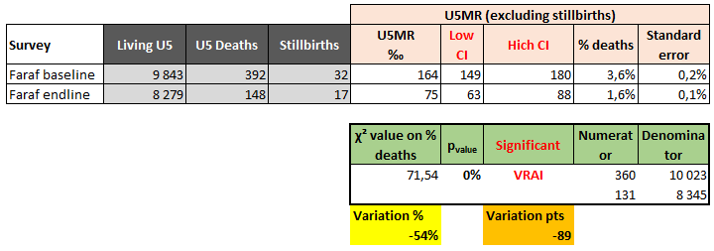

In the example above, we compare the cumulative initial surveys carried out in Farafangana in 11 communes between 2012 and 2017 with the evaluation surveys carried out in the same communes between 2016 and 2022. It shows that the 54% drop is highly significant, with a pvalue of 0% (<10-7).

## Birth history method

This method is based on cohorts of children born over a given period, using the history of all pregnancies of women in the population surveyed. It can be based on a relatively small sample (interviews with 500 mothers), but the discussion can be lengthy depending on the fertility rate in the population. This is the standard calculation used by the United Nations, particularly in the standardised DHS surveys (Demographic Health Survey).

It is divided into two approaches:

1. An approach based on a **true cohort of children**, in which the deaths of children in a specific birth cohort are divided by the number of births in that cohort. This procedure makes it possible to obtain the true probabilities of death, but has one major drawback: all the children in the cohort must have been born at least 12 months before the survey in order to be fully exposed to mortality for the U1MR, and 5 years before the survey for the U5MR. The results thus conceals the most recent trends in mortality in a given population, especially as the age group concerned is older. Another drawback is that true cohort probabilities are not specific to a particular period at death, but instead relate to the date of birth of the cohort. Therefore the effects of events that affect several cohorts at the same time, for example, a famine, appears to be spread out over time.
2. An approach based on a **synthetic cohort of children**, in which mortality probabilities for small age segments based on real cohort mortality experience are combined into the more common age segments. This approach allows full use of the most recent data and is also specific for time periods. However, the calculations required to arrive at estimated mortality are very complex.

Method **a** with a **true cohort** was used for the baseline surveys in Malawi in 2014 and 2015 and in Mozambique in 2016. Following the collection of birth histories for a sample of 400 to 500 women per zone, a list of children whose births extend from the 1980s to the days preceding the survey is recovered (see the example of Memba 2018 given in the following paragraph). We determine a period to consider, in order to create a cohort of children born in this period (**Number of children in the cohort**), and we follow what happens to these children over their first 5 years of life (still alive, or death, which makes it possible to determine the **Number of deaths in the cohort**). For the U5MR, we include children born between -10 years and -5 years before the survey. For the U1MR, children up to -1 year before the survey can be included. For the NNMR, up to 1 month before the day of the survey. The following simple formula is then applied:

|  |  |  |
| --- | --- | --- |
| **U5MR =** | **(Number of deaths before 5 years in the cohort)** |  |
| **(Number of children in the U5 cohort)** |

|  |  |  |
| --- | --- | --- |
| **U1MR =** | **(Number of deaths before 1 year in the cohort)** |  |
| **(Number of children in the U1 cohort)** |

|  |  |  |
| --- | --- | --- |
| **NNMR =** | **(Number of deaths before 28 days in the cohort)** |  |
| **(Number of children in the NN cohort)** |

Method **b** using a **synthetic cohort** is more complex. A synthetic cohort of children is created on the basis of 8 distinct age segments, divided into 3 cohorts A, B and C. This methodology was used for midline surveys in 2017 and 2020 in Malawi and in 2022 in Mozambique. The complex calculations required external support. The detailed analysis method is presented in the attached PowerPoint document (prepared by Anaïs Duchâtel), together with a standard calculation file (prepared by Piroska Bisits Bullen).

## Comparison of different calculation methods based on data from the Memba 2018 survey

A mortality survey was carried out in December 2018 in Memba district (Mozambique), after 2 years of intervention. The protocol used was that of the **birth history method**, but the dataset was used to quickly compare the different mortality calculations possible on the same data (even if the protocol did not match exactly for the other methods). This process illustrates the different methods. See **Method comparison** tab in the attached Excel file.

The survey covered 499 households in the intervention area (as well as a control area, not discussed here). The women interviewed made it possible to list 1,771 children based on their birth history, born between 1980 and 2018. The periods and indicators considered for each calculation method are presented in Appendix 4. The results obtained are as follows.

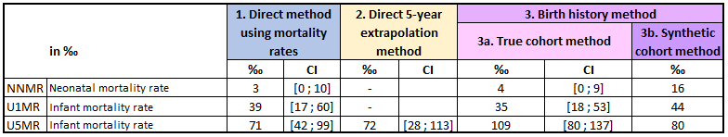

As the protocol followed method 3, it is normal that the confidence interval for method 2 is particularly large (sample too small for this method). There was a significant difference between methods 3a and 3b, particularly for the U5MR. This is logical, since the difference between the two methods mainly concerns the mortality of older children, for which the synthetic method uses more recent data. This could therefore indicate a downward trend in mortality in recent years, consistent with the intervention (as this is an evaluation survey).

# Conclusion

Measuring mortality is a particularly delicate task, but represents a major stake in the monitoring and evaluation of Inter Aide's community health projects. Each of the proposed methods has its advantages and disadvantages. Inter Aide's ambition was to define a standard protocol common to all the intervention areas, allowing reliable measurement using a methodology manageable in real conditions, and for a reasonable investment.

The aim was to be able to measure mortality in a similar and repeated way, both to compare areas between themselves (between countries or within a country), and also over time, to detect changes following the project's intervention. In addition, the surveys are carried out by teams whose skills fluctuate and are often limited in terms of implementation or analysis, both in the field and at head office. Finally, the budget and time allocated to these studies had to be taken into account in relation to the deployment of activities that directly benefit the population.

This process of identifying and reflecting on the different methods has led to the following lessons or decisions in 2022:

* The single methodology that will be used from now on is the **direct 5-year extrapolation method**. Surveys will be **exhaustive** to ensure sufficiently large samples of children (at least 3,000 live U5).
* Great care will be taken **to check the protocol beforehand and to train the survey teams** to ensure that the methods and results are standardised.
* The **involvement of local partners**, such as health authorities or public research bodies (particularly universities), will be encouraged in order to promote, gain acceptance for and/or disseminate the results obtained.
* The reliability of the surveys will be systematically represented with the results, based on **95% confidence intervals**.
* Comparisons of surveys, between zones or over time, will be made using a **χ² statistical test**.
* **Comparisons with control areas** will be systematically sought, in particular to verify the overall evolution of mortality in the country, outside Inter Aide's intervention, and to ensure the specificity of the results obtained in the action areas.
* Given the limited reliability of the results obtained (calculated in ‰, the confidence interval is always relatively large), **the detection of an evolution can only be done for a very sharp drop in mortality and using very large samples**, as was the case for the districts of Manakara and Farafangana for example. In areas where mortality is therefore relatively low before intervention (as in Vohipeno or Malawi), **it seems illusory to hope to be able to detect a drop in mortality**. On the one hand because the measurement is not sufficiently accurate, and on the other because the intervention focuses on the most basic causes of mortality, whose weight is especially significant in cases of high mortality (above 100‰).

# 

# Appendix 1 - Summary of mortality measurements between 2002 and 2023

The Excel table with the calculation formulas is available on the [Réseau Pratiques](https://reseau-pratiques.org/note-sur-les-methodes-de-mesure-de-la-mortalite-des-enfants-dans-les-programmes-de-sante-dinter-aide-2023/) or in Appendix 3.

|  |  |  |  |  |  |  |  |  |  |  |
| --- | --- | --- | --- | --- | --- | --- | --- | --- | --- | --- |
| **Country** | **District/Prefecture** | **Date** | **Communes or Health Centre** | **Step (baseline, midline, end line, control area, etc.)** | **Method\*** | **U5MR ‰** | **Low CI** | **High CI** | **Proportion of 3 diseases caused deaths** | **U5MR ‰**  **including stillbirths** |
| Madagascar | Manakara | 2002 to? | All (46) | Baseline | D5yEM |  |  |  |  | **160** |
| Madagascar | Manakara final 2015 | 2015 | All (46) | End line | D5yEM |  |  |  |  | **73** |
| Madagascar | Farafangana | 2012-2017 | 24 on 31 | Baseline | D5yEM | **153** | 147 | 159 | 46 % | **176** |
| Madagascar | Farafangana | 2012-2017 | 11 on 31 | Baseline | D5yEM | **164** | 149 | 180 | 54 % | **177** |
| Madagascar | Farafangana | 2016-2022 | 11 on 31 | End line | D5yEM | **75** | 63 | 88 | 26 % | **85** |
| Madagascar | Vohipeno | 2017-2020 | 16 on 21 | Baseline | D5yEM | **67** | 60 | 74 | 31 % | **94** |
| Madagascar | Vohipeno | 2017-2020 | 7 on 21 | Baseline | D5yEM | **66** | 52 | 80 | 22 % | **87** |
| Madagascar | Vohipeno | 2021-2023 | 7 on 21 | End line | D5yEM | **55** | 34 | 76 | 56 % | **76** |
| Madagascar | Control Vohipeno (Ikongo) | 2019 | 1 | Control baseline | D5yEM | **55** | 28 | 82 | 20 % | **104** |
| Madagascar | Control Vohipeno (Ikongo | 2022 | 1 | Control end line | D5yEM | **69** | 38 | 99 | 39 % | **79** |
| Madagascar | Vondrozo | 2022 | 2 on 18 | Baseline | D5yEM | **149** | 131 | 167 | 43 % | **167** |
| Madagascar | Vangaindrano | 2023 | 3 on 34 | Baseline | D5yEM | **147** | 136 | 159 | 52 % | **181** |
| Malawi | Lilongwe | 2014 | Maluwa | Baseline | BHM-true | **151** | 106 | 197 | 38 % | **-** |
| Malawi | Lilongwe | 2014 | Katchale | Baseline | BHM-true | **114** | 86 | 142 | 50 % | **-** |
| Malawi | Phalombe | 2015 | Nambazo | Baseline | BHM-true | **84** | 61 | 107 | 37 % | **-** |
| Malawi | Phalombe | 2015 | Kalinde | Baseline | BHM-true | **101** | - | - | - | **-** |
| Malawi | Phalombe | 2022 | Nazombe | Evaluation or midline | D5yEM | **48** | 34 | 61 | 38 % | **67** |
| Malawi | Phalombe | 2022 | Nambiti | Evaluation or midline | D5yEM | **21** | 7 | 35 | 44 % | **21** |
| Malawi | Phalombe | 2022 | Waruma | Evaluation or midline | D5yEM | **43** | 29 | 57 | 32 % | **80** |
| Malawi | Lilongwe | 2022 | Chiunjiza | Evaluation or midline | D5yEM | **47** | 34 | 61 | 18 % | **66** |
| Malawi | Lilongwe | 2022 | Chiwosa | Evaluation or midline | D5yEM | **32** | 20 | 44 | 8 % | **53** |
| Malawi | Lilongwe | 2023 | Maluwa + Dickson | Evaluation or midline | D5yEM | **75** | 31 | 116 | 27 % | **81** |
| Malawi | Phalombe | 2023 | Chitekesa | Baseline | D5yEM | **37** | 27 | 46 | 11 % | **62** |
| Malawi | Phalombe | 2023 | Mwanga | Baseline | D5yEM | **25** | 12 | 37 | 27 % | **46** |
| Malawi | Mchinji | 2023 | Gum+Fan+Chim | Baseline | D5yEM | **23** | 14 | 32 | 21 % | **34** |
| Mozambique | Memba | 2016 | Caleia + Chipene | Baseline | DM | **79** | 46 | 112 | **-** | **-** |
| Mozambique | Memba | 2018 | Caleia + Chipene | Evaluation or midline | DM | **71** | 42 | 99 | **-** | **-** |
| Mozambique | Monapo | 2016 | Itoculo + Ramiane | Baseline | BHM-true | **102** | 76 | 127 | **-** | **-** |
| Mozambique | Monapo | 2018 | Itoculo + Ramiane | Evaluation or midline | BHM-synthetic | **39** | - | - | **-** | **-** |
| Mozambique | Memba | 2018 | Caleia + Chipene | Evaluation or midline | BHM-synthetic | **80** | - | - | **-** | **-** |
| Mozambique | Memba | 2021-2022 | Chipene | Evaluation or midline | D5yEM | **120** | 81 | 156 | 62 % | **129** |
| Mozambique | Monapo | 2022 | Murruto | Baseline | D5yEM | **143** | 127 | 158 | 32 % | **171** |
| Mozambique | Memba | 2022 | Pavala | Baseline | D5yEM | **94** | 71 | 117 | 66 % | **108** |
| Mozambique | Monapo | 2023 | Meserepane | Baseline | D5yEM | **137** | 102 | 170 | 51 % | **180** |
| Mozambique | Monapo | 2023 | Metocheria | Baseline | D5yEM | **79** | 57 | 100 | 23 % | **82** |
| Mozambique | Mogincual | 2023 | Xa-Momade | Baseline | D5yEM | **131** | 104 | 157 | 42 % | **163** |
| Mozambique | Mogincual | 2023 | Xa-Selemane | Baseline | D5yEM | **126** | 98 | 153 | 54 % | **146** |
| Guinea | Kankan | 2022 | Tinti Oulen | Baseline | D5yEM | **251** | 229 | 272 | 60 % | **301** |
| Guinea | Kankan | 2022 | Mamouroudou | Baseline | D5yEM | **308** | 280 | 336 | 49 % | **369** |
| Guinea | Kankan Control (Kerouane) | 2023 | Soromaya | Control | D5yEM | **304** | 279 | 328 | - | **341** |

*\* DM : Direct Method*

*D5yEM: Direct 5-year extrapolation method*

*BHM : Birth history method*

*\*\* Malaria, diarrhoea, acute respiratory infections*

# Appendix 2 - Reference documents

Document 1 is an external evaluation of the community health programme in Madagascar carried out in 2007 by Dr David Masson and Dr Mamy Tiana Rakotoarimana (in French). It validated the **direct 5-year extrapolation method**, while highlighting its limitations:

**Document 1:** Évaluation externe du programme de lutte contre la mortalité infantile à Manakara, Madagascar (IA – STEPS / F3E 2007)

[Link to the study report and appendices](https://reseau-pratiques.org/evaluation-externe-du-programme-de-lutte-contre-la-mortalite-infantile-a-manakara-madagascar-ia-steps-f3e-2007/)

Documents 2 and 3 provide a better understanding of the standard mortality measurement protocols used by the United Nations. In particular, they detail the direct **method using mortality rates** and the **birth history method** (calculation based on true and synthetic cohorts).

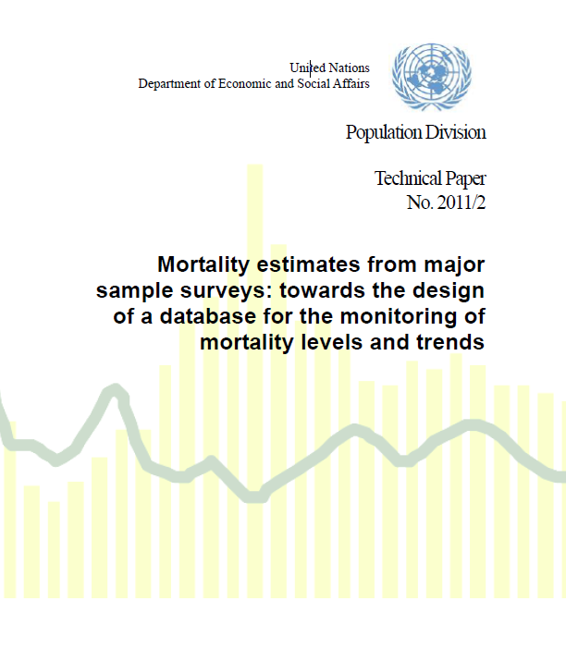**Document 2:** Mortality estimates from major sample surveys: towards the design of a database for the monitoring of mortality levels and trends

Information on the document is available here: <https://www.un.org/development/desa/pd/content/mortality-estimates-major-sample-surveys-towards-design-database-monitoring-mortality-levels>

The document can be downloaded here: <https://www.un.org/en/development/desa/population/publications/pdf/technical/TP2011-2_MortEstMajorSampSurv.pdf>

Or click directly on this icon:



**Document 3:** Guide to DHS Statistics - DHS-7 (version 2) - The Demographic and Health Surveys Program

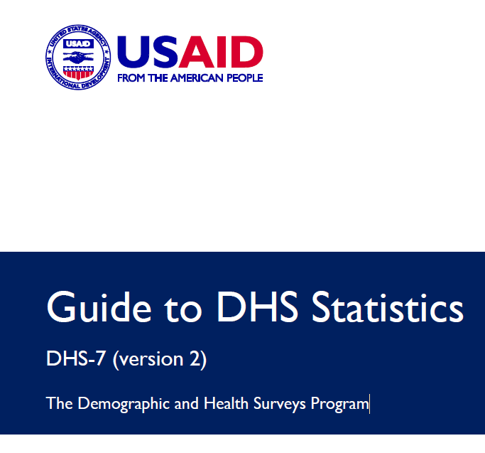See page 311 (paragraph 8).

The document can be downloaded here: <https://www.dhsprogram.com/publications/publication-dhsg1-dhs-questionnaires-and-manuals.cfm>

Or read it online here: <https://dhsprogram.com/Data/Guide-to-DHS-Statistics/>

Or click directly on this icon:



# Appendix 3 - Tools and forms for each method

Various documents are available on request from the contact given at the beginning of the document: detailed survey protocols, training manuals for supervisors and interviewers, paper and digital questionnaires (Kobo), data entry files, analysis tools and databases, etc.

The attached Excel document lists the different results obtained using each method, details the formulas to be used, and presents a comparison of the methods for the Memba 2018 survey:



## Direct method using mortality rates

**Extract from the questionnaire used in Vangaindrano (Madagascar) in 2023:**

|  |  |  |  |  |  |  |
| --- | --- | --- | --- | --- | --- | --- |
|  | **Commune :** |  | **Fokontany :** | | **Date :** | |
| 1 | N° maison | | 1 | 2 | 3 | 4 |
| 2 | Nom du père | |  |  |  |  |
| 3 | Nom de la mère | |  |  |  |  |
| 4 | Nombre de femmes (plus de 15 ans) | |  |  |  |  |
| 5 | Nombre d'hommes (plus de 15 ans) | |  |  |  |  |
| 6 | Nombre de jeunes (5 à 14 ans) | |  |  |  |  |
| 7 | Nombre d'EM5 vivants (<5ans) | |  |  |  |  |
| 8 | Nombre d'occupants (doit être le total des lignes 4 à 7) | |  |  |  |  |
| 9 | Naissances sur les 12 derniers mois (ou selon repère temporel) | |  |  |  |  |
| 10 | EM5 décédés sur les 12 derniers mois (ou selon repère temporel) | |  |  |  |  |
| 11 | Age du décès | |  |  |  |  |
| 12 | Cause du décès | |  |  |  |  |
| 13 | Diarrhée d'EM5 15 jours derniers | |  |  |  |  |
| 14 | Fièvre d'EM5 15 jours derniers | |  |  |  |  |
| 15 | Autre maladie d'EM5 dans les 15 derniers jours | |  |  |  |  |
| 16 | Si maladie, qu’avez-vous fait en premier ? | AC |  |  |  |  |
| 17 | CSB |  |  |  |  |
| 18 | Médecine traditionnelle |  |  |  |  |
| 19 | Plante |  |  |  |  |
| 20 | Boutique |  |  |  |  |
| 21 | Pharmacie ou dépôt |  |  |  |  |
| 22 | Autre |  |  |  |  |
| 24 | Nombre d'EM5 dormant sous moustiquaire en bon état | |  |  |  |  |
| 25 | Nombre d'EM5 dormant sous moustiquaire en mauvais état | |  |  |  |  |
| 26 | Nombre d'EM5 qui ne dorment pas sous moustiquaire | |  |  |  |  |
| 27 | Nom du répondant | |  |  |  |  |

**Extract from the external evaluation carried out in 2007, concerning the link between sample sizes and the desired precision, according to the U5MR:**

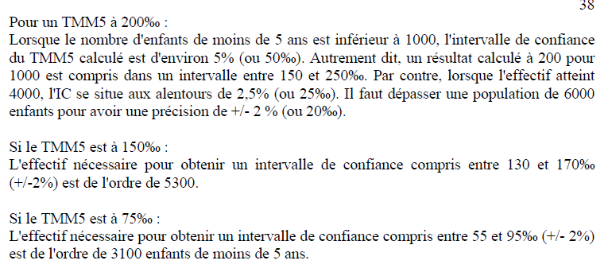

## Birth history method

The full protocol for the 2014 Malawi survey is available here: [link to the survey report on the Réseau Pratiques](https://reseau-pratiques.org/enquetes-initiales-pour-le-projet-de-sante-materno-infantile-en-zone-rurale-au-malawi-2014-et-2015/).

A specific PowerPoint presentation on the calculation based on a synthetic cohort is attached to the document: Mortality rate - Synthetic Cohort Method - Methodology _20200904, as well as a sample calculation file Mortality rate - Synthetic Cohort Method - Template_ 20200506.

 

**Extract from the questionnaire used in Malawi in 2014:**

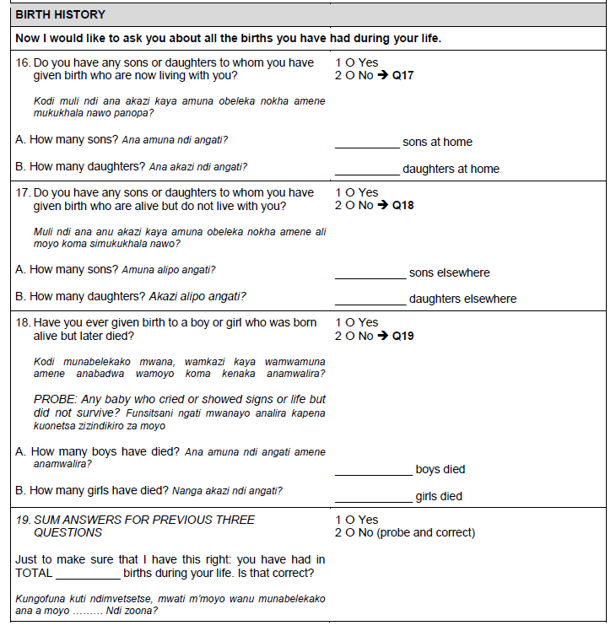

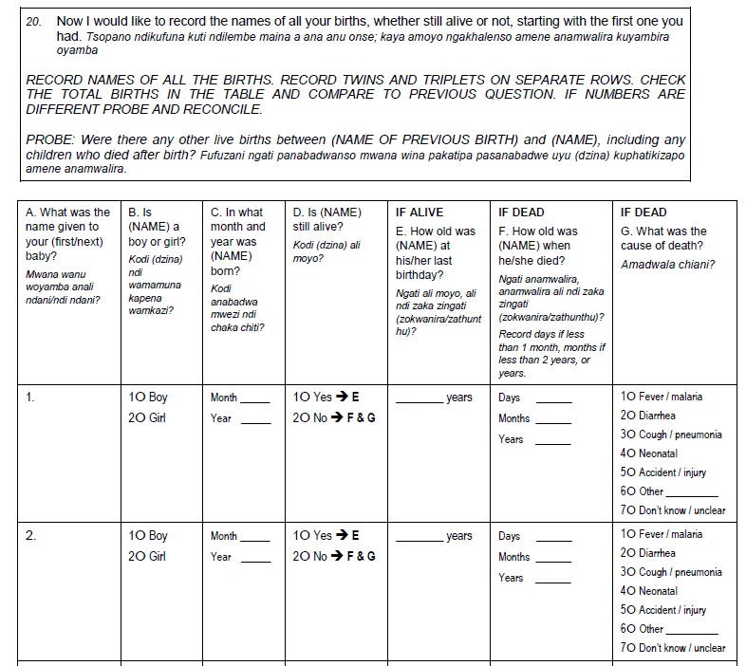

Repeated up to 11 children

# Appendix 4 - Details of the comparison of methods for Memba 2018

**Periods and indicators considered for each calculation method**

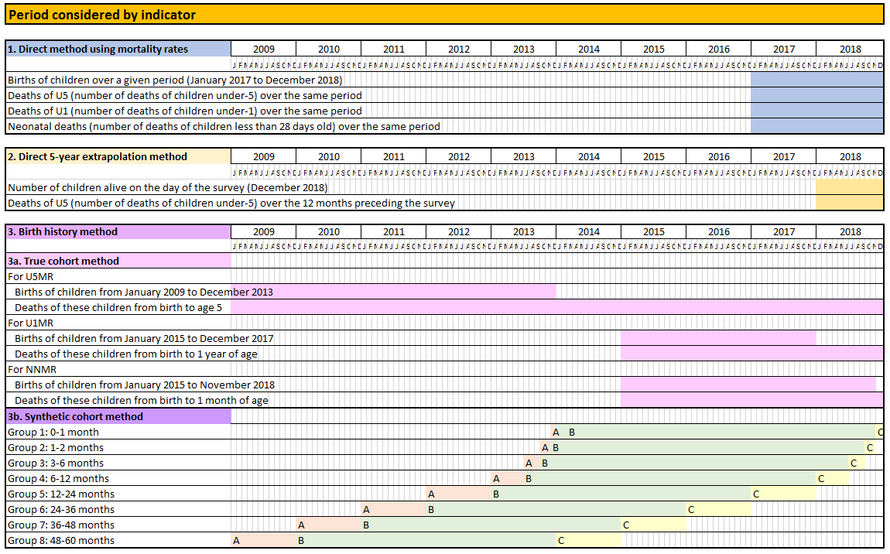

1. I do not know if this principle really applies to U5MR and NNMR, as the DHS protocol only mentions U1MR. Nevertheless, I have made the calculations for comparison.